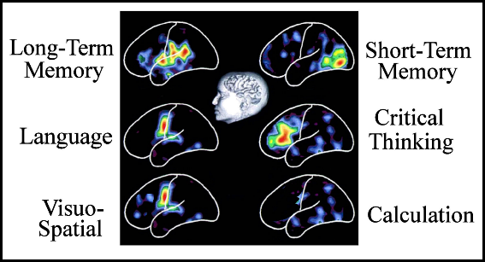***Brain Fitness…Use It OR Lose* *It!* Brain Fitness Education DEHYDRATION** Source: aarp.org

Dehydration-definition from Webster’s: 1. The loss or removal of water from something 2. "a vegetable dehydration factory"A harmful reduction in the amount of water in the body

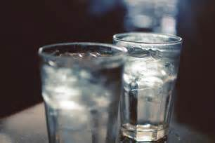Recent studies have found that even mild [dehydration](http://healthtools.aarp.org/galecontent/dehydration-2) may come with big consequences: *altered mood *impaired memory *headaches **ALL COULD BE AVOIDED WITH >>>>** *constipation

According to the lead author of one study, older people are more susceptible to dehydration. That's because, after about age 50, our ability to recognize thirst decreases, and our kidneys lose some of their precision in regulating the body's water supply, says Lawrence Armstrong, a researcher with the University of Connecticut Human Performance Laboratory.

Additionally, some common medications add to the problem, including [diuretics](http://healthtools.aarp.org/galecontent/diuretics) (taken for high blood pressure), antihistamines, and certain psychiatric drugs. Finally, people who start drinking less because of bladder control problems are at even higher risk.

**One of The BIGGEST Concerns for Seniors is**  **Impaired Memory and Concentration**

While the reasons for these symptoms aren't yet clear, researchers at the University of Connecticut Human Performance Laboratory note that dehydration causes changes in electrolyte balances in the blood, which directly affect parts of the mind responsible for reasoning. Changes in [electrolyte levels](http://healthtools.aarp.org/galecontent/electrolyte-disorders) also can alter brain levels of serotonin, which influences mood. Some additional signs of dehydration in seniors may include:

Confusion Difficulty walking Dizziness or headaches Dry mouth Sunken eyes Inability to sweat or produce tears Rapid heart rate Low blood pressure Low urine output

***Why Put Yourself At Risk… When the Solution is so Simple?* This material may not be published, broadcast, rewritten or redistributed in whole or in part without express written permission of** Tee Barr,[**info@keys2brainfitness.com**](mailto:info@keys2brainfitness.com)**,** *Brain Fitness...Use It OR* *Lose It!* developer, designer, and instructor.

***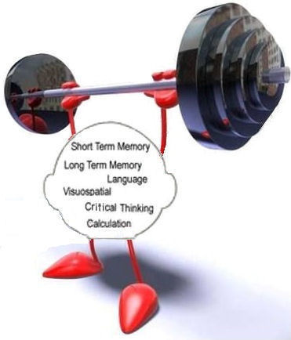*BRAIN FITNESS EXERCISE *Focus is Key*…**

**Focus Focus Focus!**

**Focus Focus Focus!**

**YOUR MEMORY WILL SAY THANK YOU!**

***You can’t Remember Something You Don’t Know!***



Drink more water source: tenor.com-Robin Koontz

**This material may not be published, broadcast, rewritten or redistributed in whole or in part without express written permission of** Tee Barr, [**info@keys2brainfitness.com**](mailto:info@keys2brainfitness.com)**,** *Brain Fitness...Use It OR* *Lose It!* developer, designer, and instructor.